Creating an expense report for CGS Ohana Committee

Please note: Only Managers and above should be creating these expense reports. The process is as follows:

1. Anytime you need to expense a CGS Ohana Committee gift or prize, please email either Julia Kantarovsky, Shellina Warnack-Martin, or Sam Burn the following:
   1. The names and emails of the recipients
   2. The amounts
   3. The specific gift type (should usually be an amazon gift card)
   4. The **subject line** and **content (see CGS Ohana Branding)** of the outgoing email. This should describe what the gift is and why they are receiving it.
   5. Timeline for gift receipt
2. Once you have confirmed receipt from Julia, Shellina, or Sam, check in with them and coordinate when the gift should be sent and when the ‘thank you/congrats’ email should be sent (if relevant).

Go to Deltek > Time & Expense > Expense > Expense Reports

[@Kantarovsky, Julia](mailto:julia.kantarovsky@capgemini-gs.com)

Create a Non Travel Business Expense using the Wizard Mode > Click “Continue”

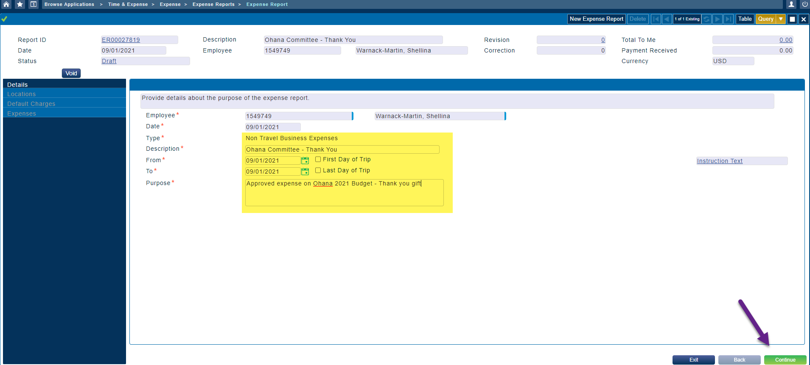

Add your location > Click “Continue”

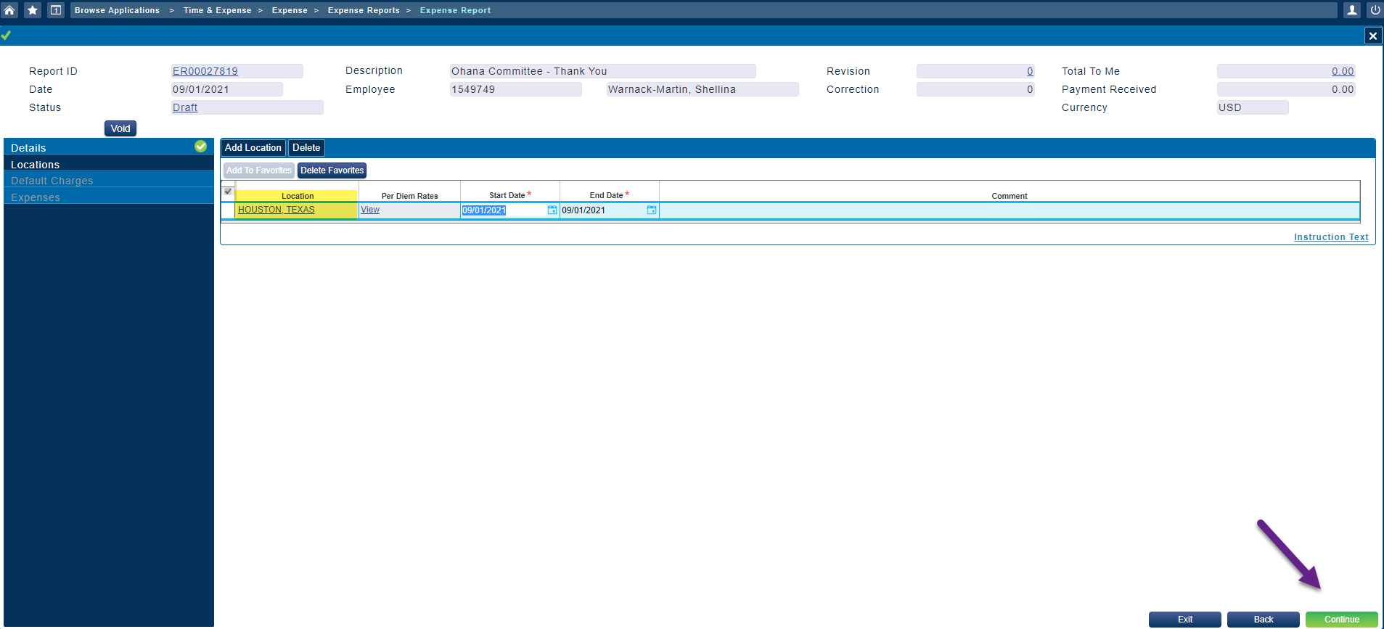

Add Charge (OVRHD.FEDBN.CUST) > Click “Select” > Click “Update Report”

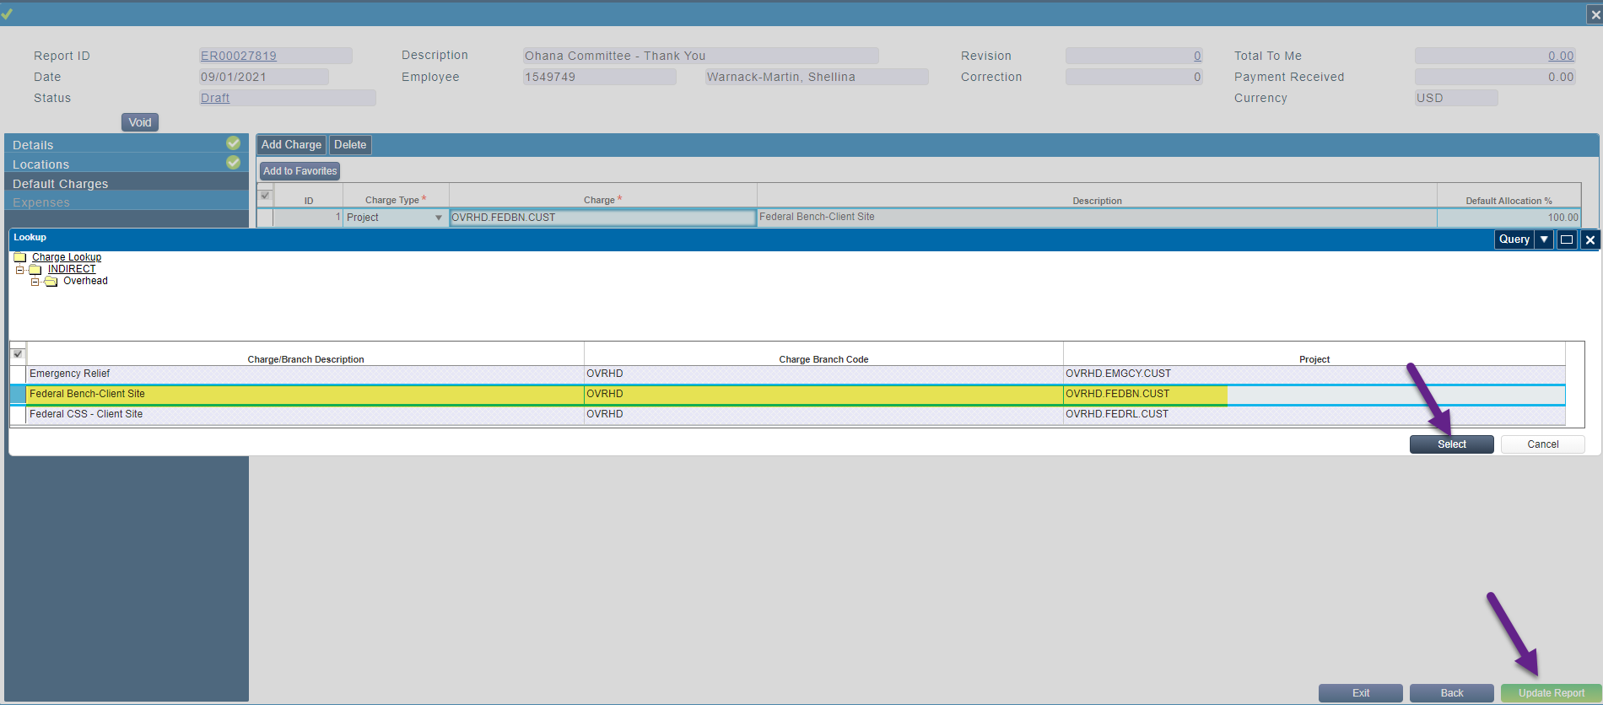

Add Expense Type “Indirect Costs – EE Engagement Rewards” > Click “Select” > Click “Continue”

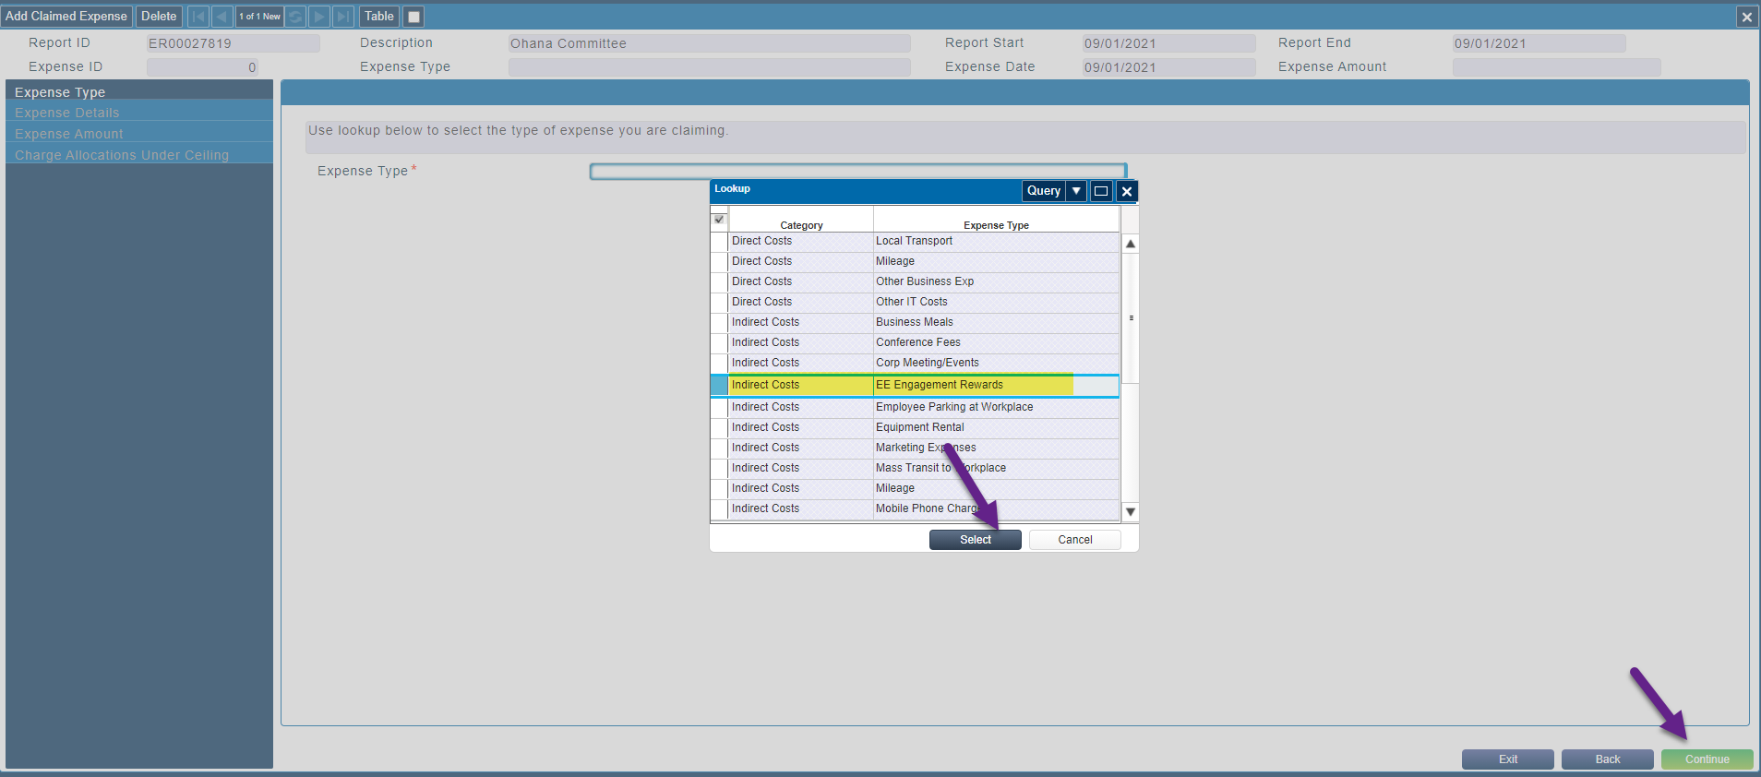

Add Comments > Click “Continue”

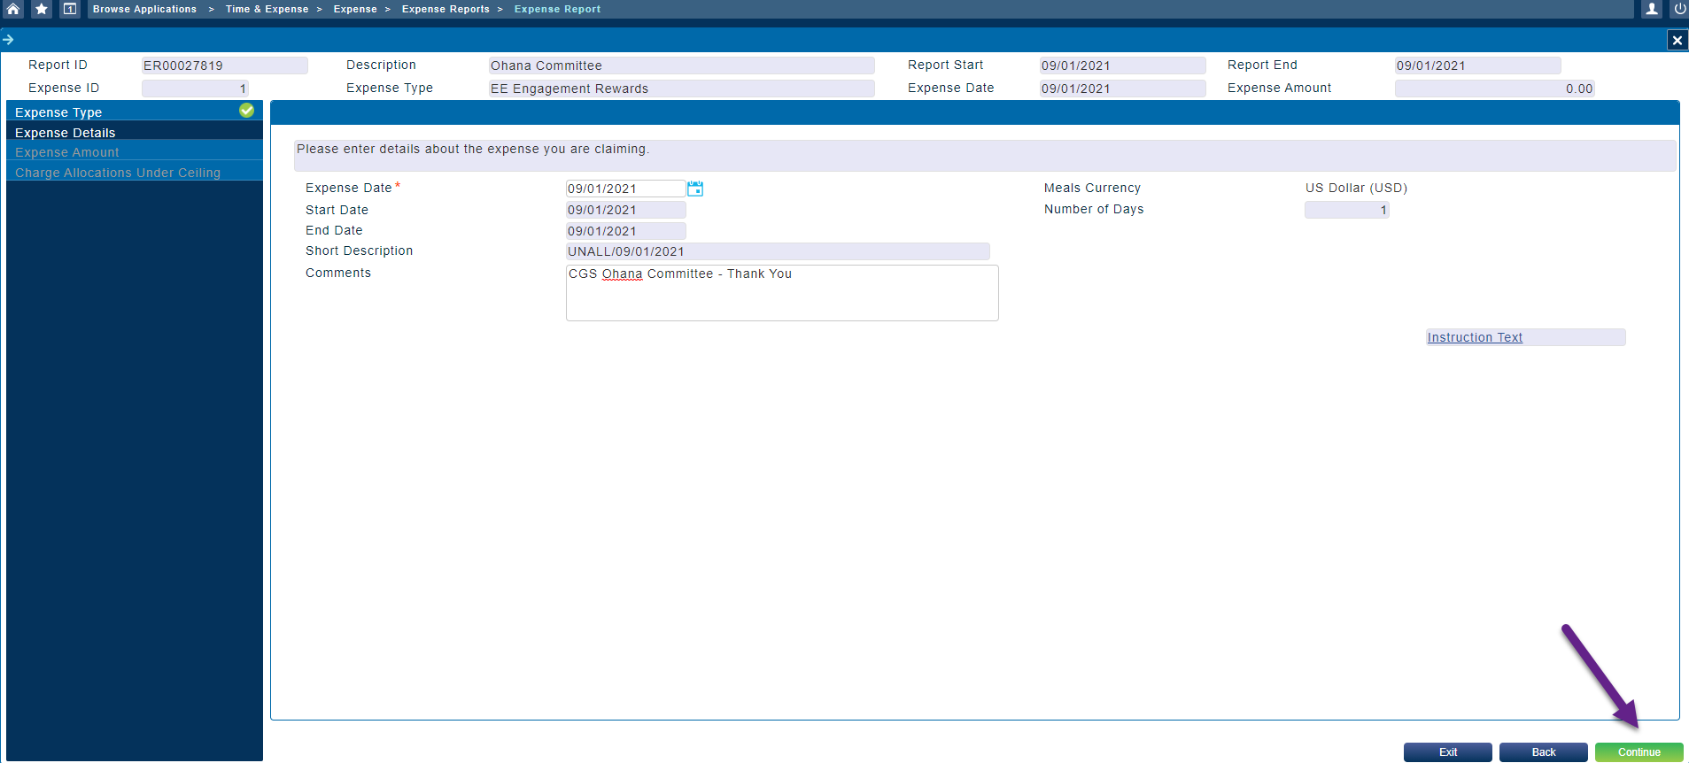

Select Payment Method “Employee Paid” > add the Expense Incurred amount > Click “Continue”

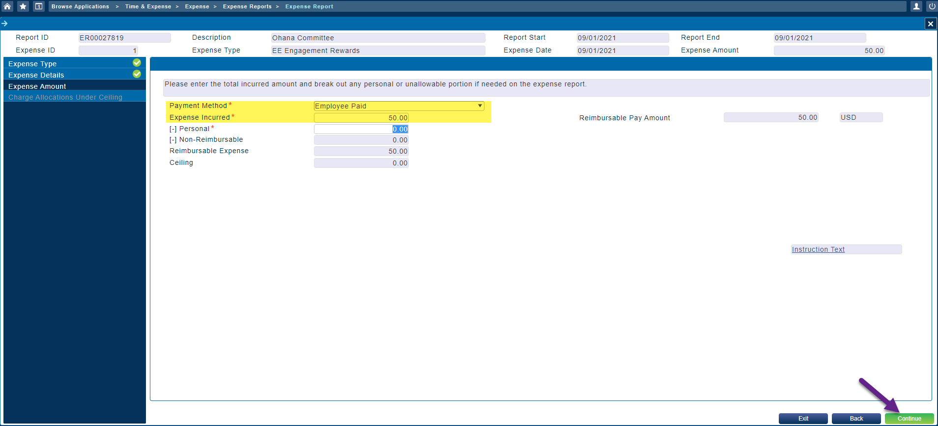

Click “Save Expense”

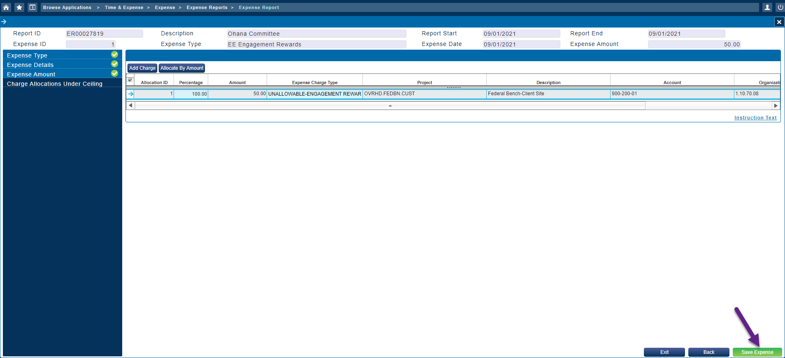

Click “Submit”

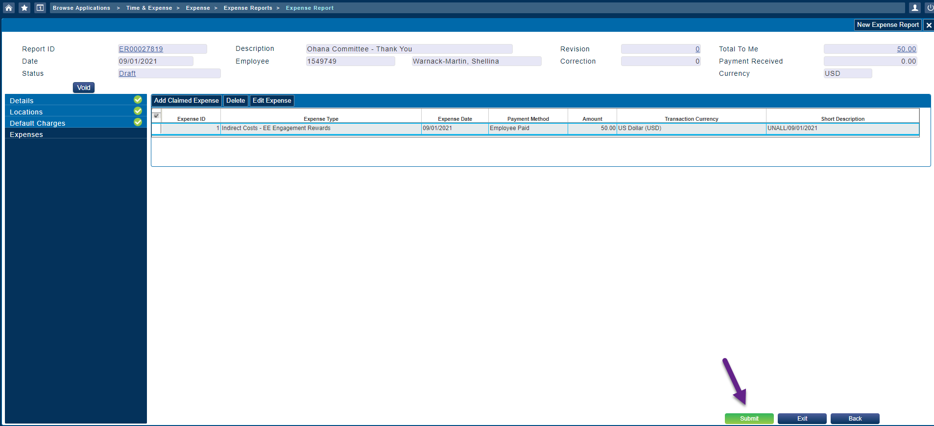

Click the check box for “I Agree” > Click “Update Report”

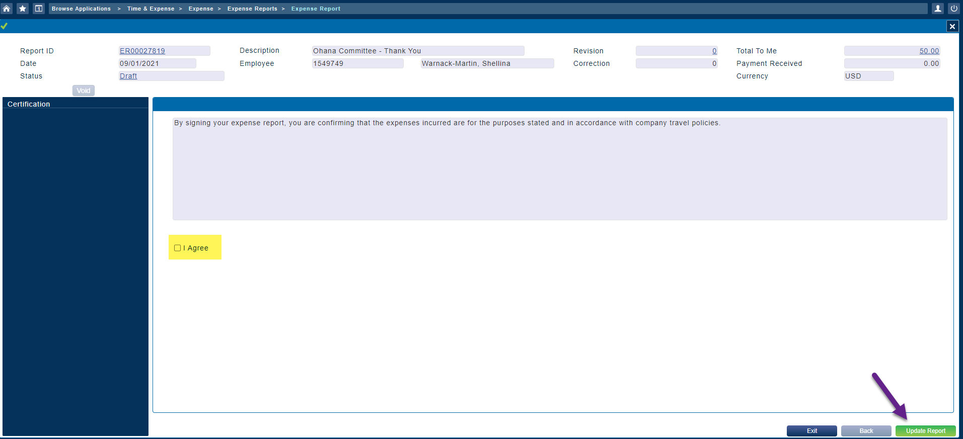

Now you have a submitted Expense Report waiting for manager approval

